Quality Armature, Inc.

5259 W. Grand Ave. Tel: (773) 622-3951
Chicago, IL 60639 Fax: (773) 622-3952
Website: www. Qualityarmature.com
E-mail: qualityarmature@sbcglobal.net

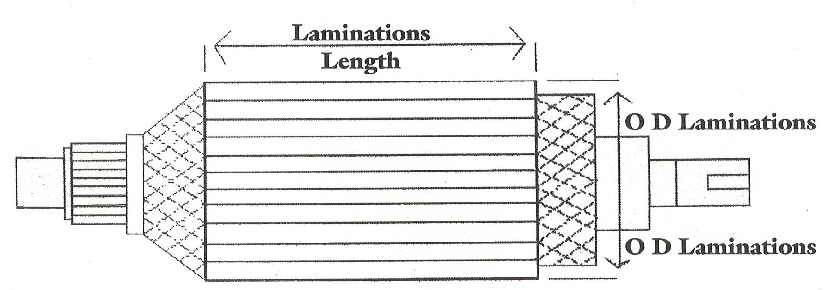
ARMATURE REWING QUOTATION FORM
Company Name |  |  | Contact Name
Address |  |  |  |  | Date
City |  | State |  |  | Zip
Phone # | Fax # |  |  | Job # | P.O. #

Lamination
Manufacturer |  | Frame
HP | RPM |  | # Of Slots
O D Lamination | Lamination Length |  | Shaft Length
Commutator
# Of Bars | Bar Length with Riser | Commutator Diameter | Riser Diameter
Bore | V-Ring | Circle one of the Following Refillable Molded Steel
Wire
Circle one of the Following Round Wire Rectangular Wire | If Rectangular Wire More than one turn 1 Turn
Rewind Time
Circle one of the following Regular Time Overtime Stock armature and rewind on free time

Estimate valid for 30 days. Please save this as a Master Copy
Comments_____________________________________________________________________________________________________________________________________________________________________________________________________________________________________________________________________

