Quality Armature, Inc.

5259 W. Grand Ave. Tel: (773) 622-3951
Chicago, IL 60639 Fax: (773) 622-3952
Website: www. Qualityarmature.com
E-mail: qualityarmature@sbcglobal.net

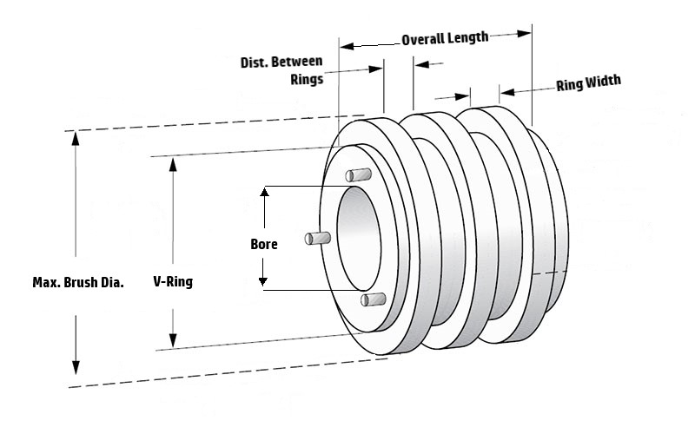
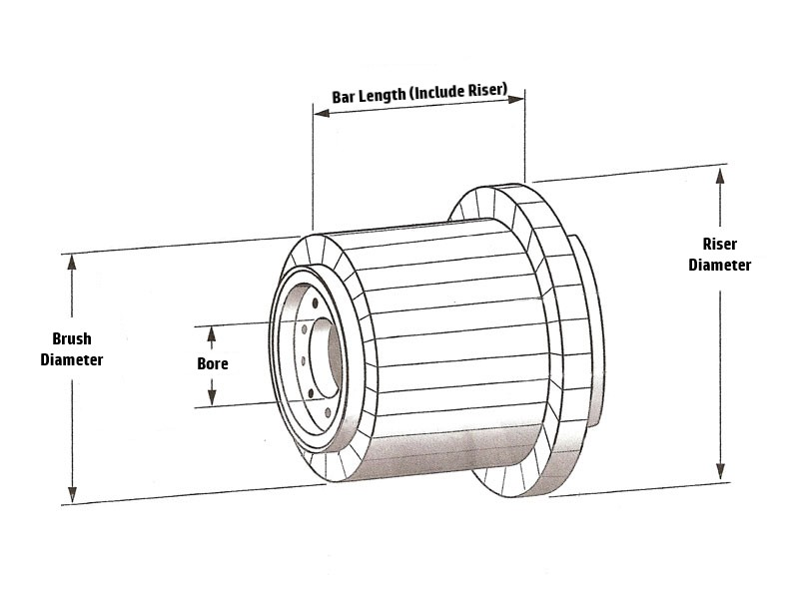
COMMUTATORS QUOTATION FORM
Company Name |  |  | Contact Name
Address |  |  |  |  | Date
City |  | State |  |  | Zip
Phone # | Fax # |  |  | Job # | P.O. #

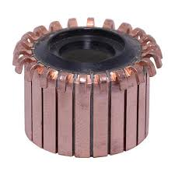
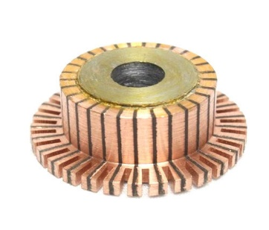
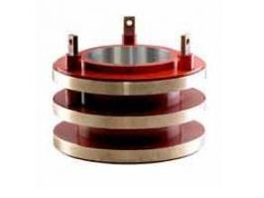

TYPE | HOOK / SLOTTED / SLIP RING | CLOSEST DIMENSIONS AVAILABLE (For Quality’s Use Only)
QUANTITY
# OF BARS / # OF RINGS
BORE (I.D)
BRUSH DIAMETER
RISER DIAMETER
BAR LENGTH (WITH RISER)
RING THICKNESS
SPACE BETWEEN RINGS
 | PRICE:

