Quality Armature, Inc.

5259 W. Grand Ave. Tel: (773) 622-3951
Chicago, IL 60639 Fax: (773) 622-3952
Website: www. Qualityarmature.com
E-mail: qualityarmature@sbcglobal.net

FIELD FRAM QUOTATION FORM
Company Name |  |  | Contact Name
Address |  |  |  |  | Date
City |  | State |  |  | Zip
Phone # | Fax # |  |  | Job # | P.O. #
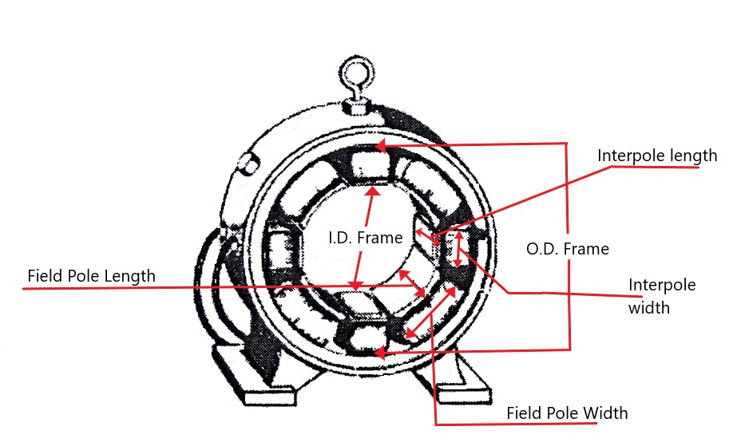

Field Pole Length | Field Pole Width |  | Interpole Width |  | Interpole Length
How many Fields | Circle one for Fields:  Round Wire Rectangular Wire |  | How many Interpoles |  | Circle one for Interpoles:  Round Wire Rectangular Wire
HP | RPM |  | Manufacturer |  | Frame
Voltage |  | O.D. Frame |  | I.D. Frame
Stabilizing Coils: YES or NO |  | Circle one for Stabilizing Wire:  Round Wire Rectangular Wire |  | Seriesg Coils: YES or NO

Estimate valid for 30 days. Please save this as a Master Copy

Comments_____________________________________________________________________________________________________________________________________________________________________________________________________________________________________________________________________

