Quality Armature, Inc.

5259 W. Grand Ave. Tel: (773) 622-3951
Chicago, IL 60639 Fax: (773) 622-3952
Website: www. Qualityarmature.com
E-mail: qualityarmature@sbcglobal.net

STATOR QUOTATION FORM
Company Name |  |  | Contact Name
Address |  |  |  |  | Date
City |  | State |  |  | Zip
Phone # | Fax # |  |  | Job # | P.O. #

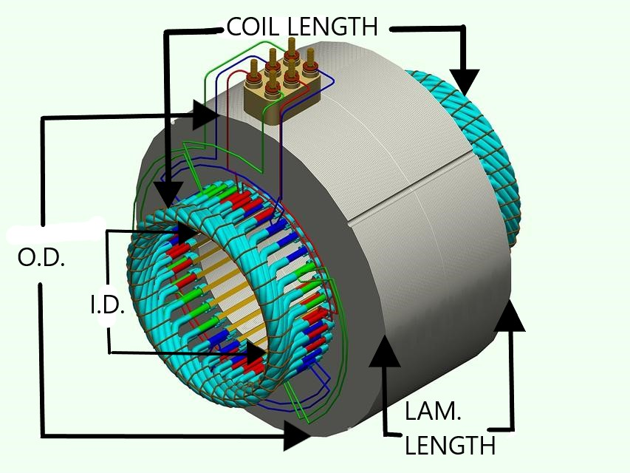

Manufacturer |  | H.P. / K.W. 1 | H.P. / K.W. 2
RPM 1 | RPM 2 | RPM 3 | RPM 4
Phases | Frame | Speeds | Hz
Voltage | # of Slots | I.D. | Lam. Length
Coil Length | O.D. | Please circle one: Flat Wire Round Wire

Estimate valid for 30 days. Please save this as a Master Copy
Comments_____________________________________________________________________________________________________________________________________________________________________________________________________________________________________________________________________

